**Visual Art**

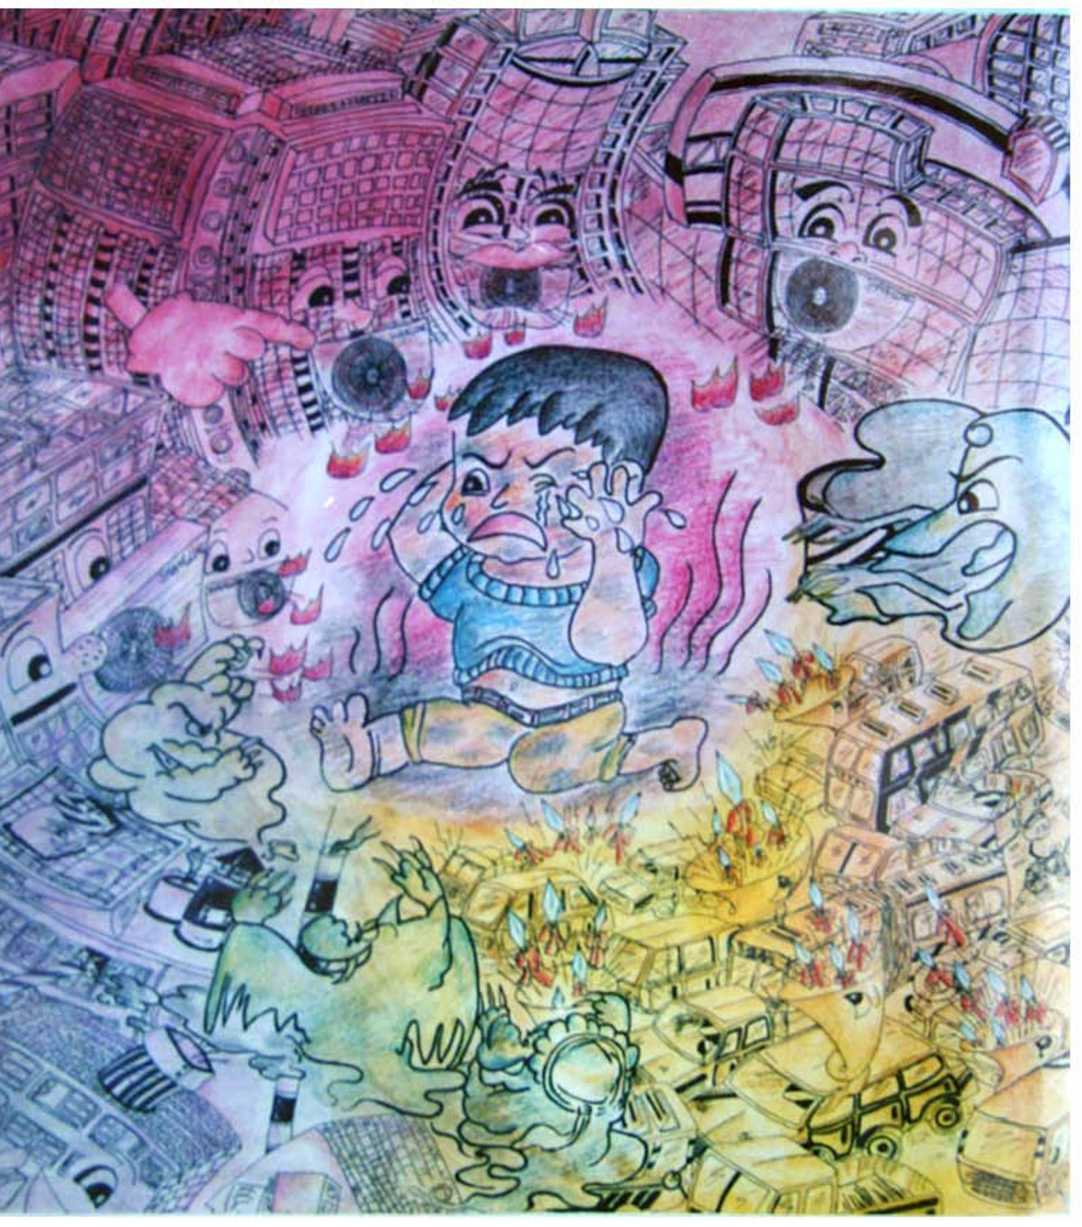

Jane Zheng, 1996, Three Demons in Urbanization, the 2nd Runner up in the “Painting Competition on Urbanization in Asia Ministerial Conference,” United Nations and the Pacific and CITNET, Thailand.

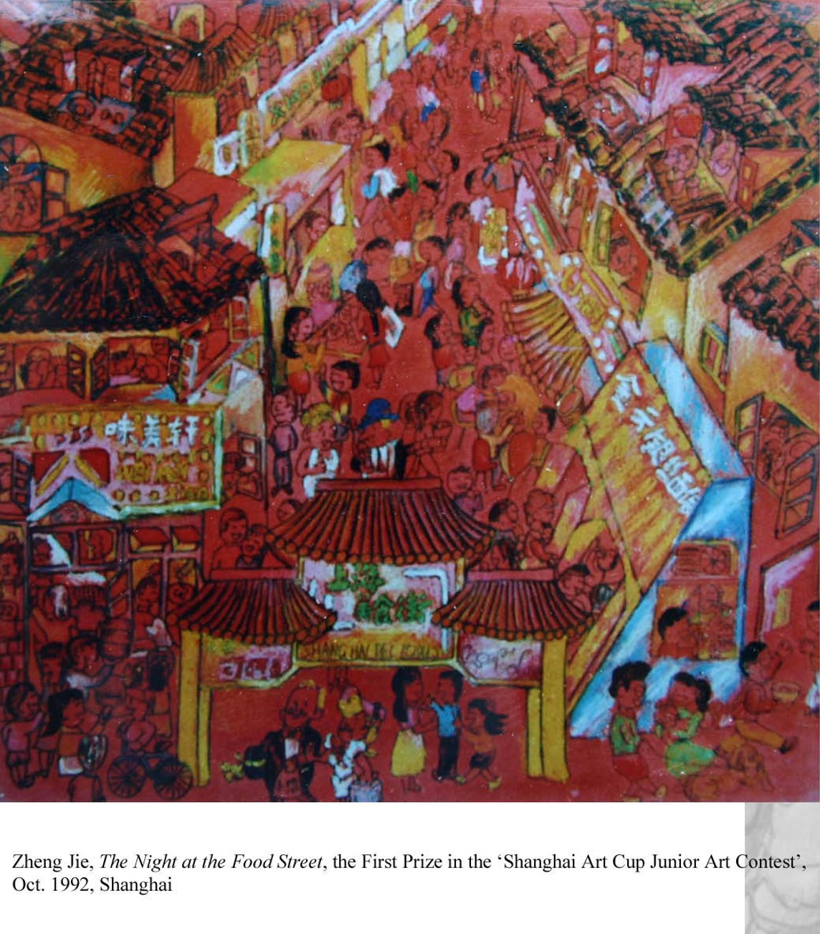

Jane Zheng, 1992, *Lightening up the Food Street in Shanghai*, champion in the “Shanghai Art Cup” Art Student Painting Contest, Shanghai

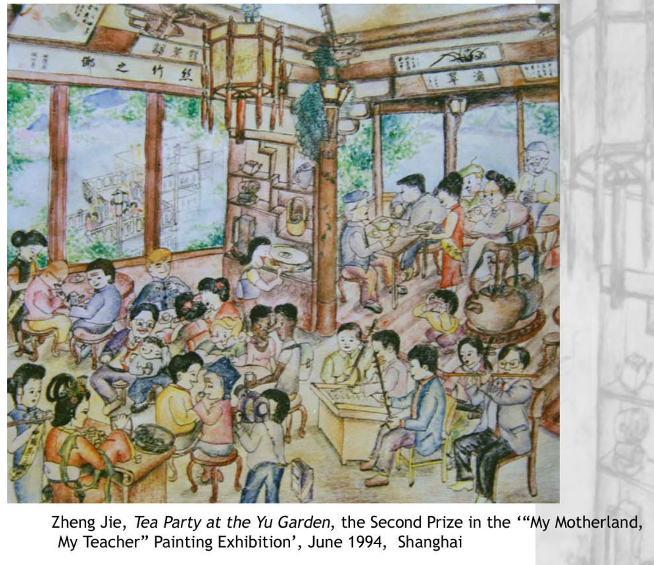

Jane Zheng, 1994, *Tea Gathering in Yu Garden in Shanghai*, First Runner up in ‘My Teacher, My Motherland’ Painting Contest, Shanghai.

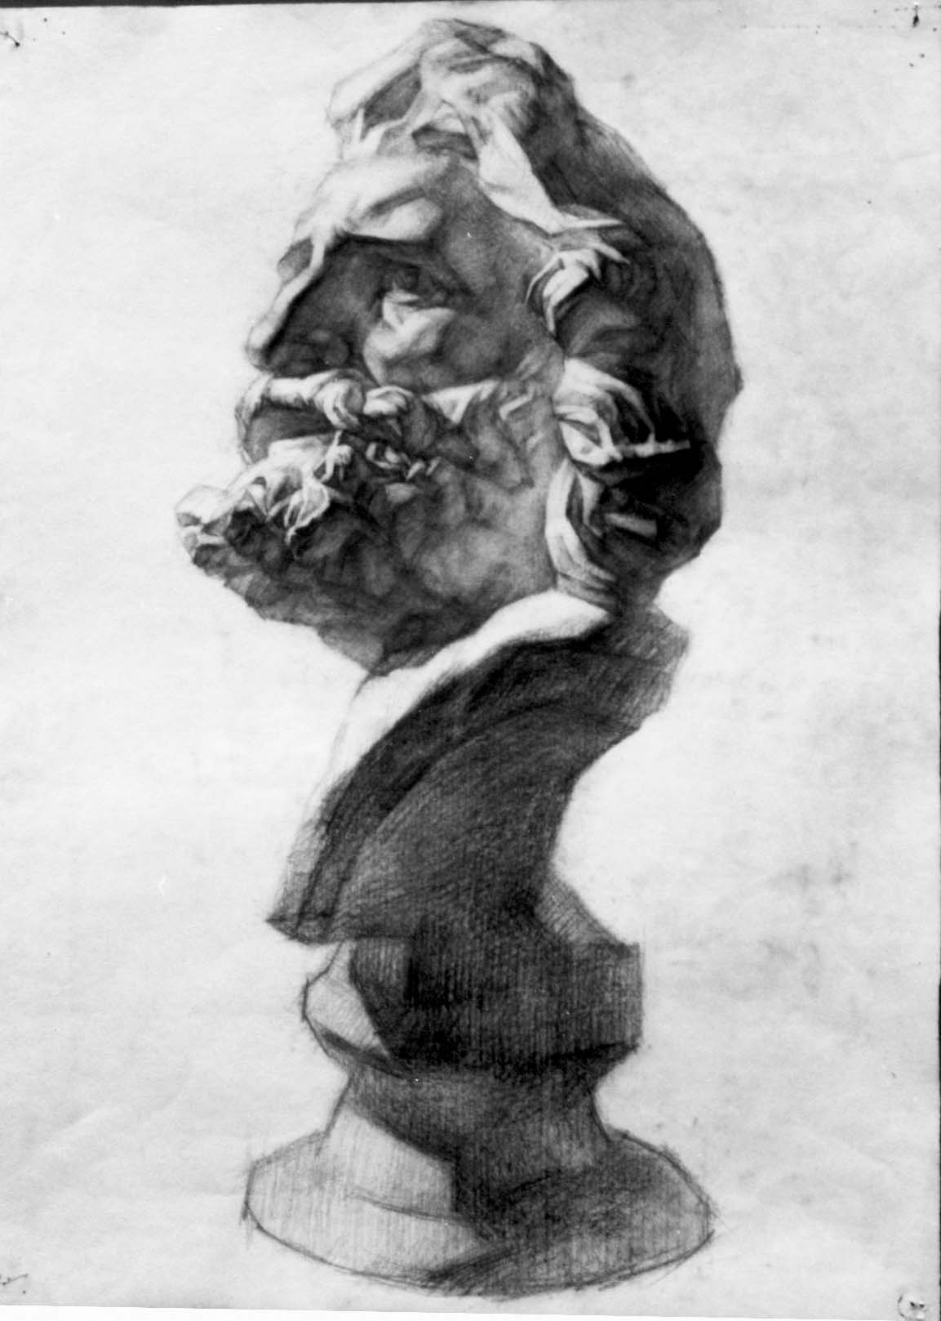

Jane Zheng, 1995, *Plaster Statue Sketch 1*

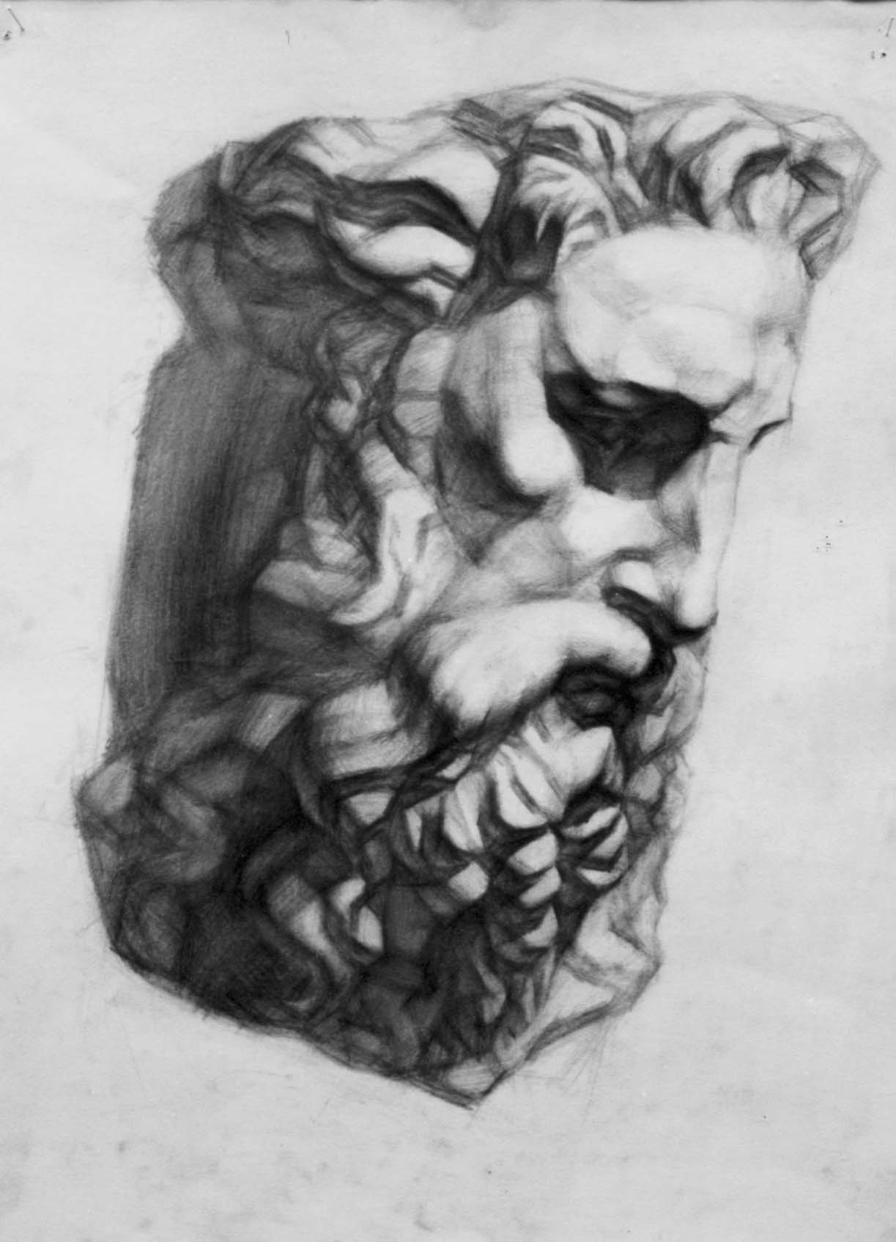

Jane Zheng, 1995, *Plaster Statue Sketch 2*

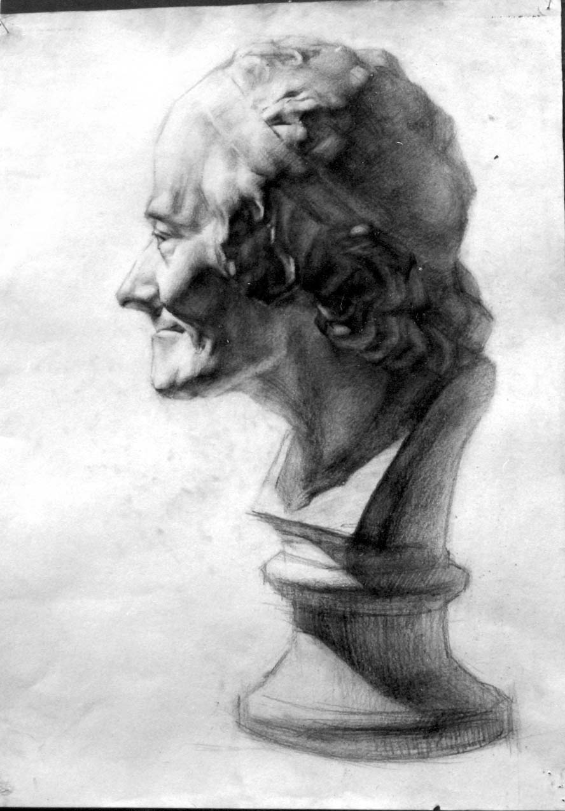

Jane Zheng, 1995, *Plaster Statue Sketch 3*

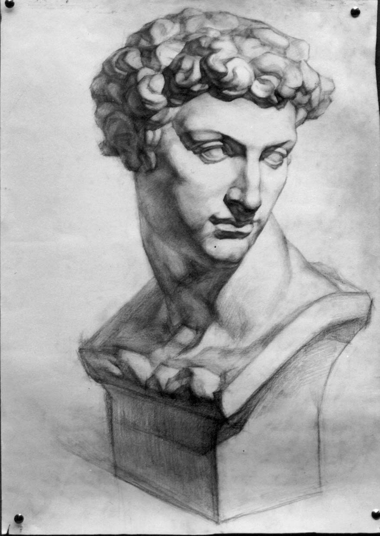

Jane Zheng, 1995, *Plaster Statue Sketch 4*

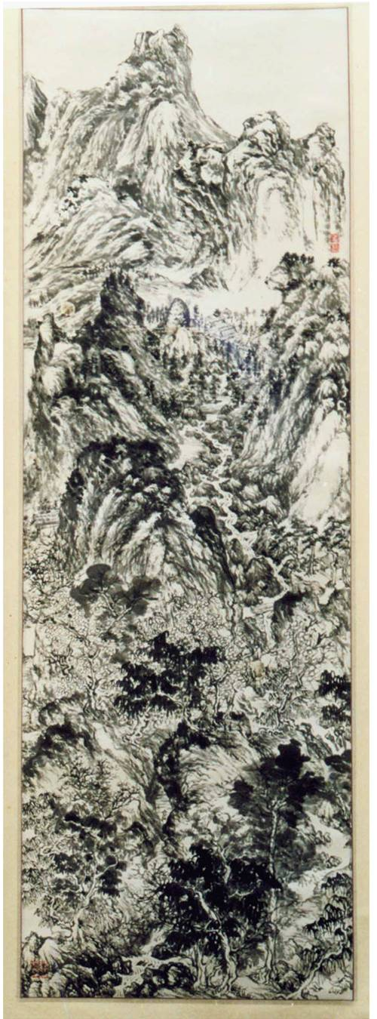

Jane Zheng, 2000, *Landscape Painting after Yuan Master Wang Meng’s Style*

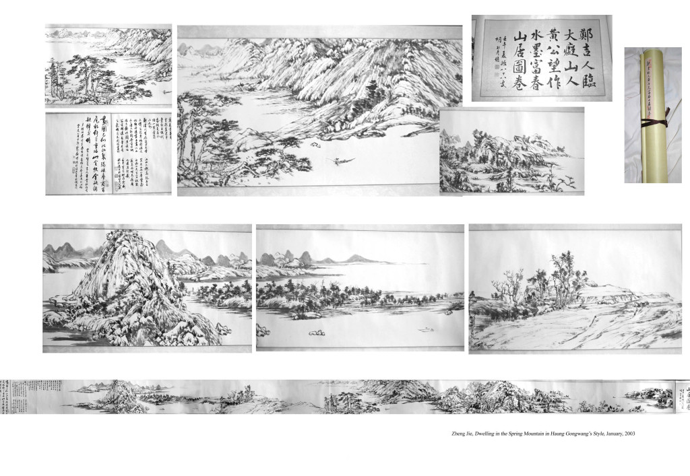

[clicking on this painting leads to the three below, interconnected using arrow buttoms]

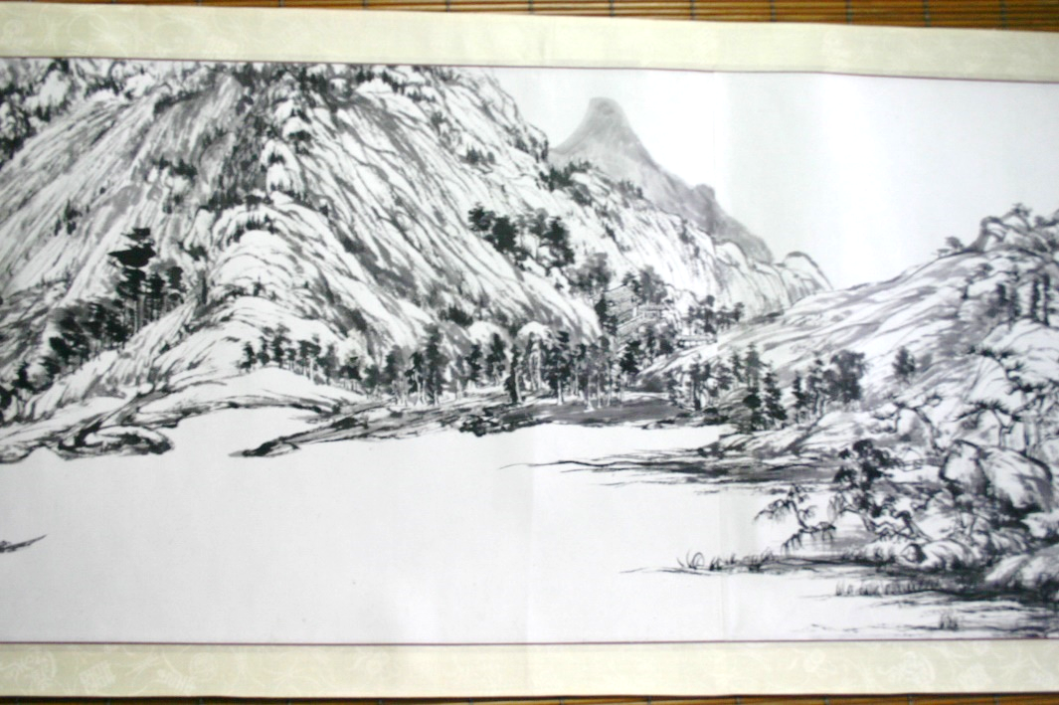

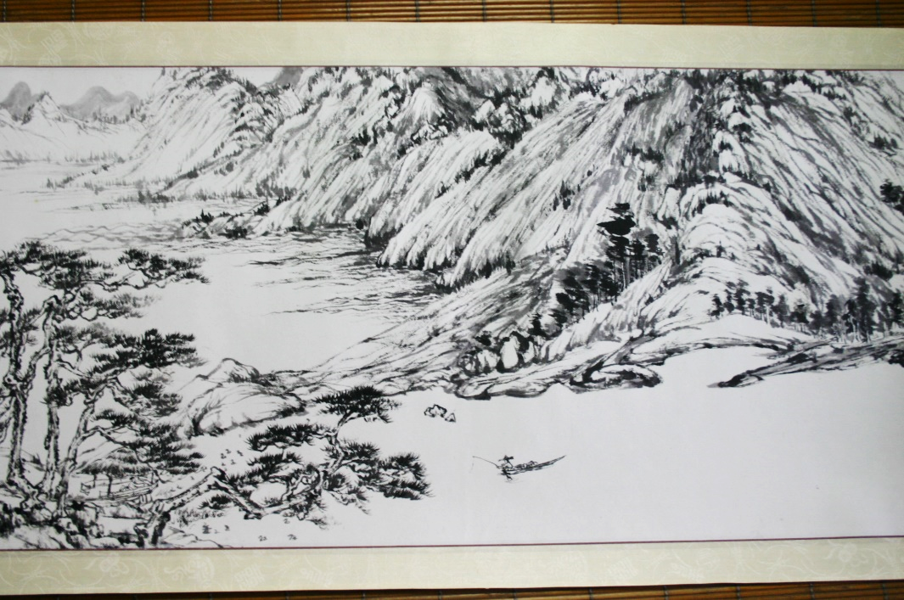

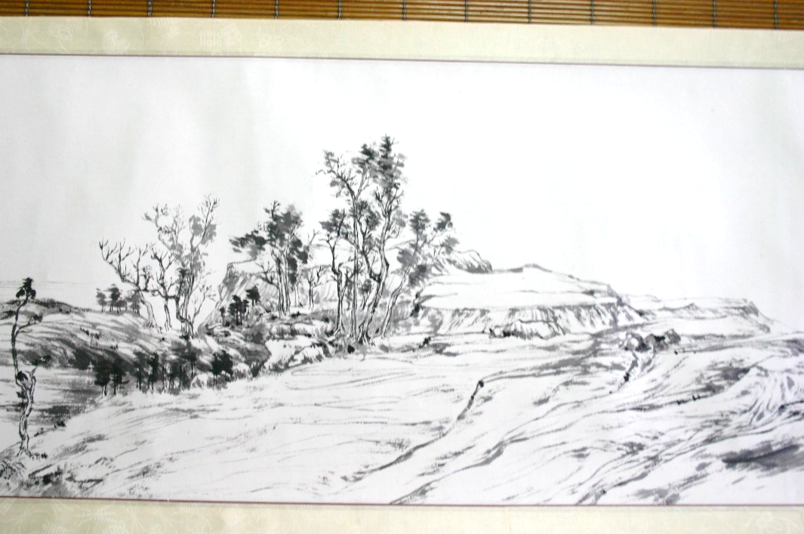

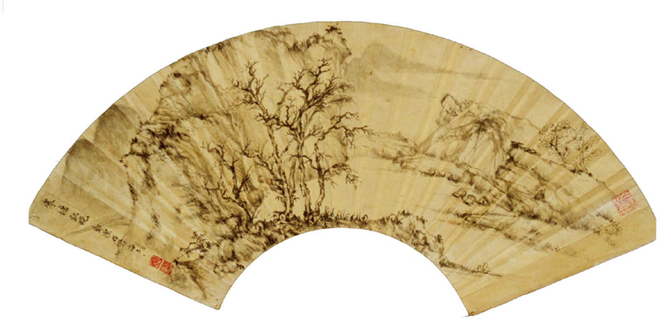

Jane Zheng, 2001, *Fan Painting*

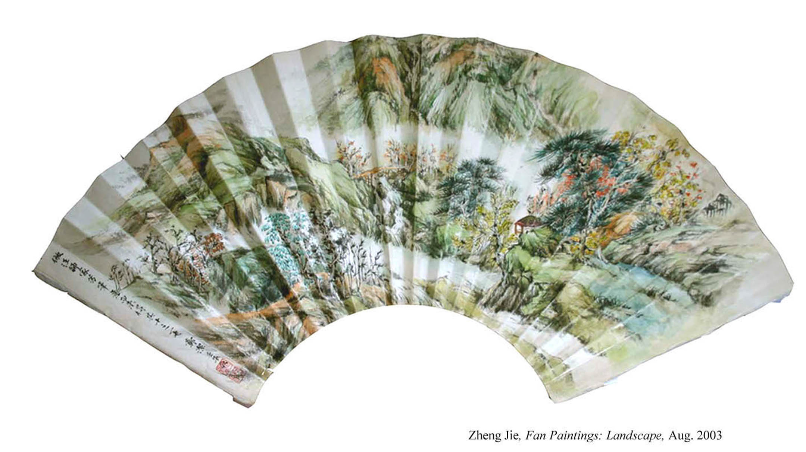

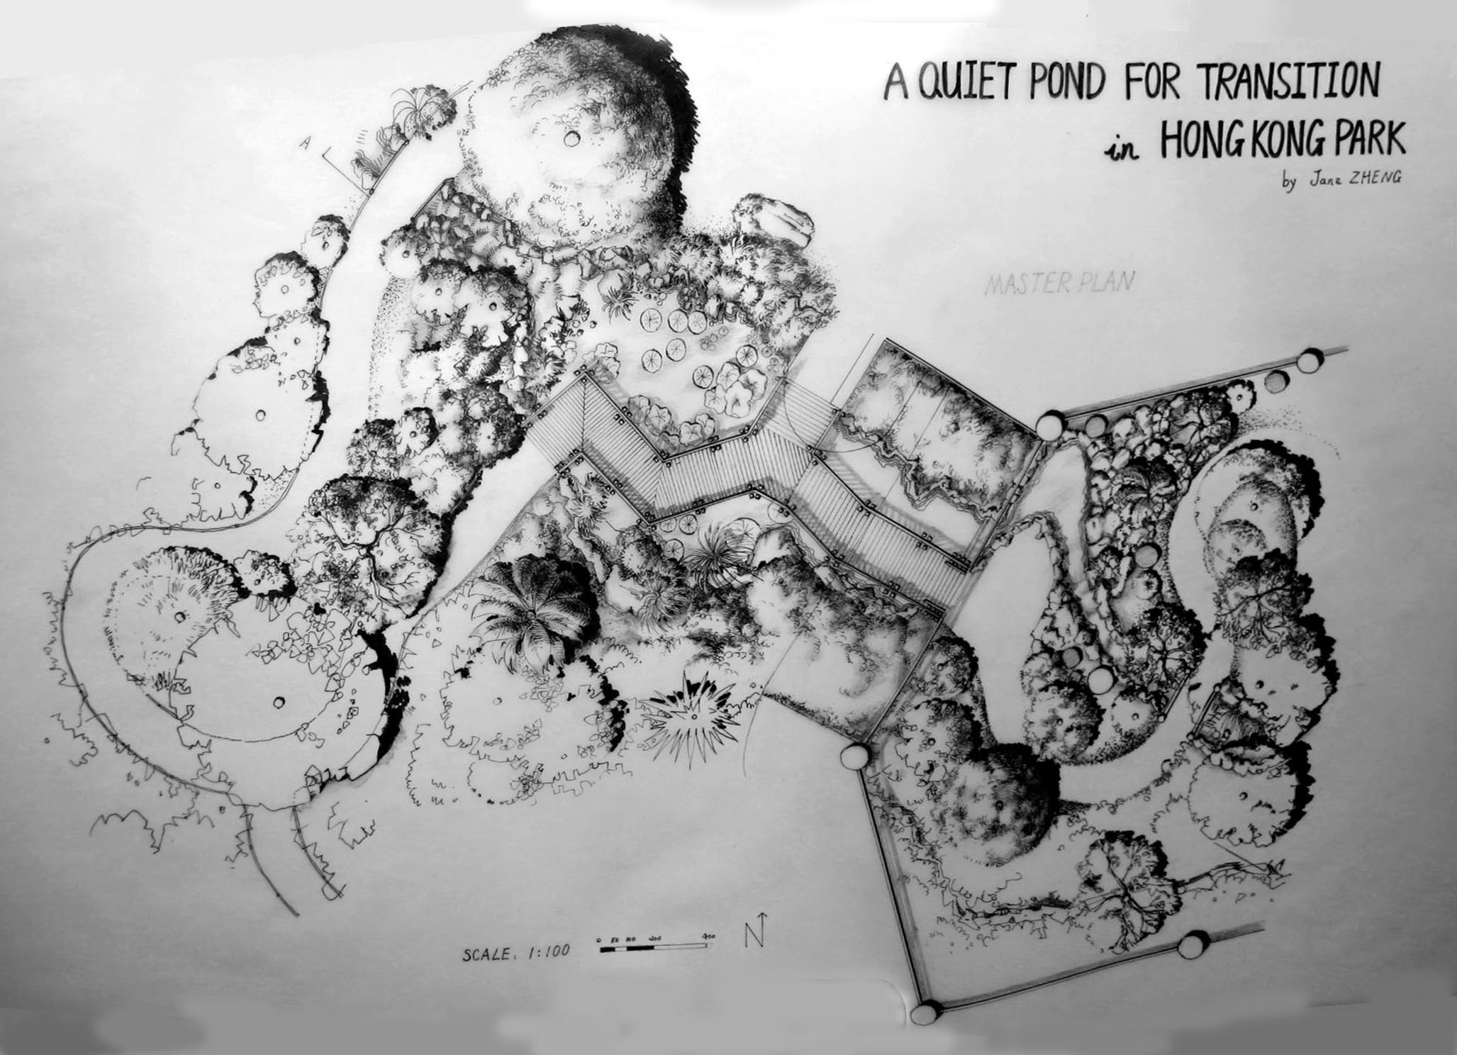

Jane Zheng, 2006, *A Quiet Pond for Transition in Hong Kong Park* [Garden Design]

[Clicking on this painting leads to the two below, interconnected using arrow buttons]

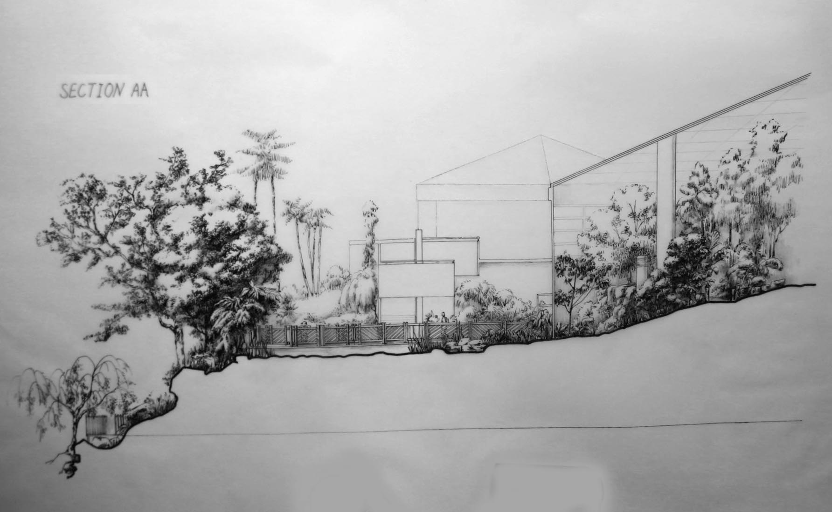

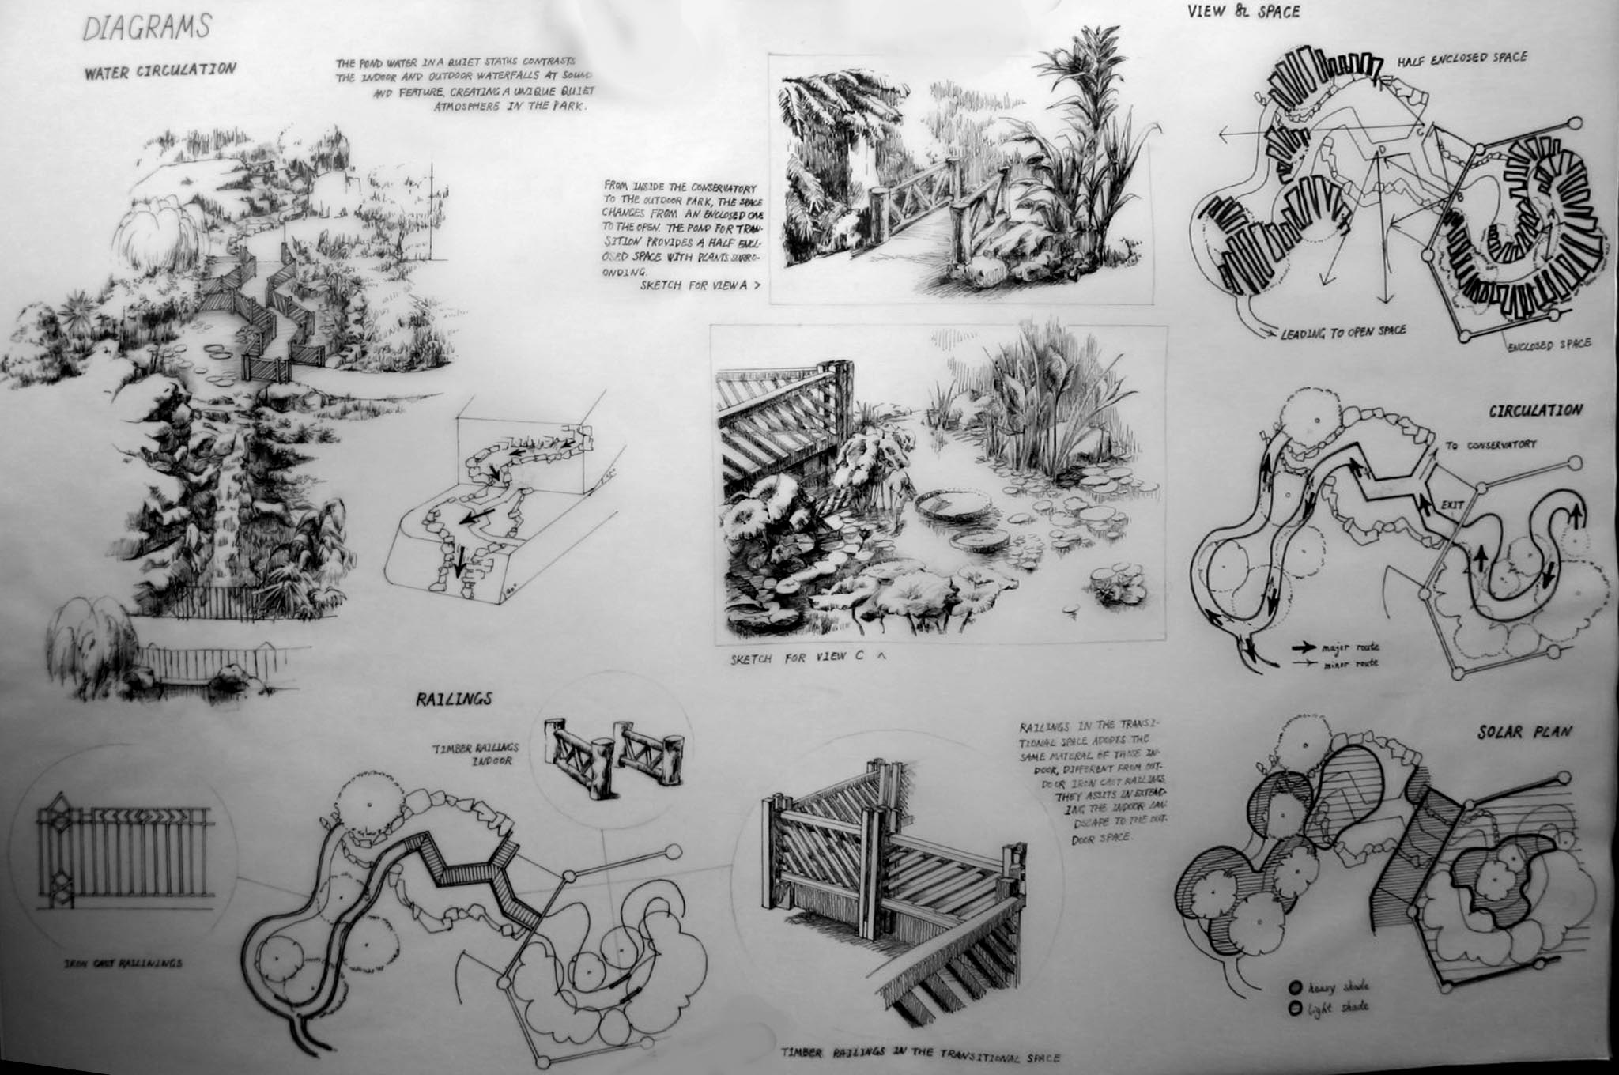

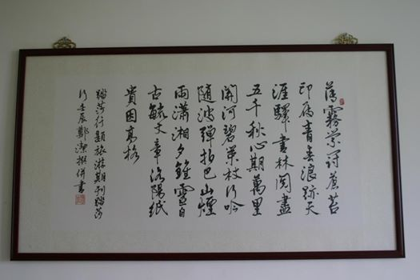

Jane Zheng, 2012, *Poetry for the Founding Issue of Tasuoxing Tourism Magazine* [Poetry and Calligraphy]

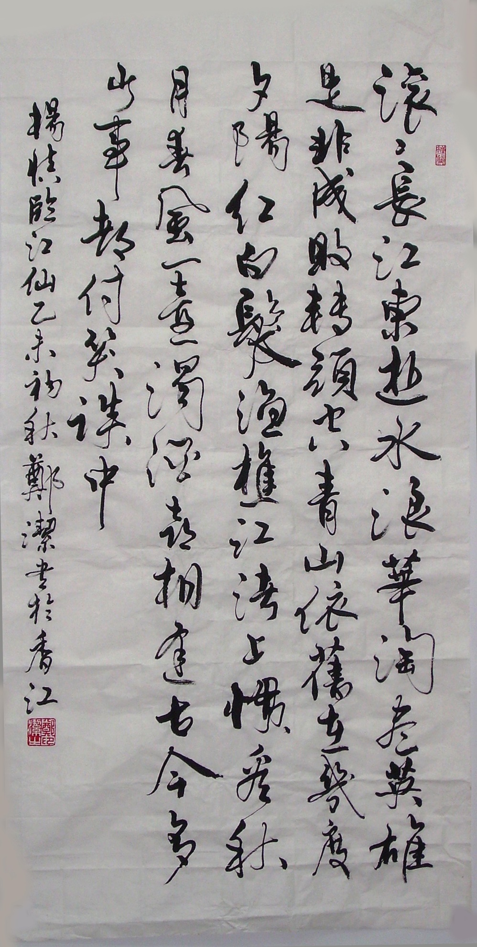

Jane Zheng, 2016, Lingjiangxian Prose [Calligraphy]

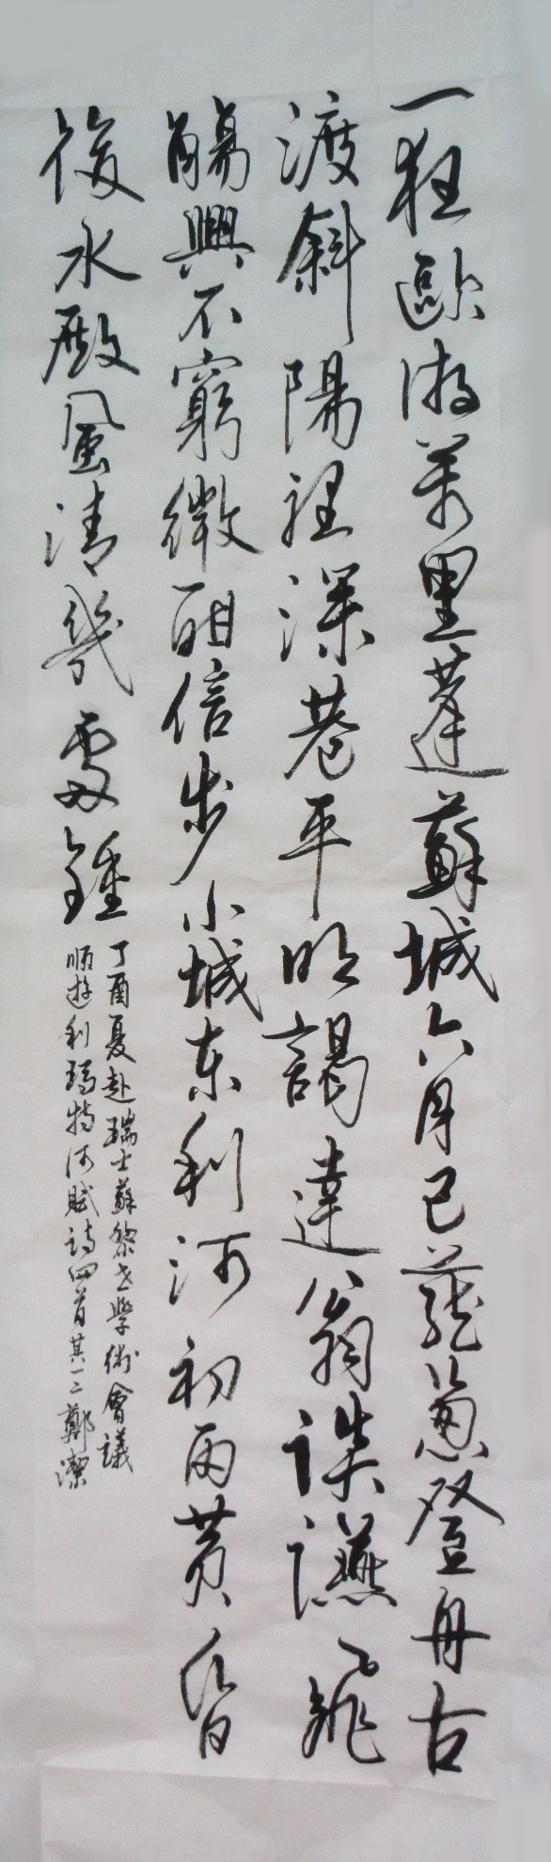

[Clicking on this work leads to the two below, interconnected using arrow buttons]

Jane Zheng, 2017, Four Poems composed during my Conference Trip to Zurich, Switzerland [Poetry and Calligraphy]

